1. 
2. Don’t change .git manually.
3. Git has its own file system .git and inside this, objects dir where git stores the following objects.
   1. These objects are used by git to track files and changes in files.
      1. **Blob**: Any kind of file is stored as blob.
      2. **Tree**: To store directory info. Dir maybe empty or contain other files and/or directories.
         1. Tree is set of blobs (files) and/or other trees (dirs)
      3. **Commit**: This object is used to store different versions of our project.
      4. **Annotated Tag:** Text pointer to other commits.  
         **NOTE**: In this section, we will talk about BLOB & Commit objects.
4. **Low Level Commands**:
   1. Will use the following commands to manage BLOB, TREE objects.
   2. **git hash-object**: To create git object.
   3. **git cat-file**: To read git object.  
      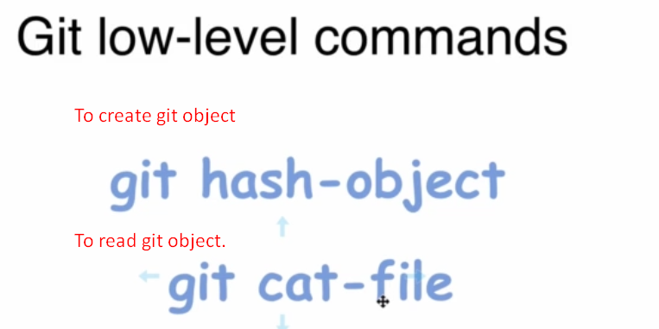  
      **NOTE**: git hash-object can create only git BLOB object.
5. Let’s see these commands in next lec.